**High emissivity materials for Mariner barrel**

NV + Mariner team, Sept. 2021

As the temperature decreases, the peak of the emitted black-body radiation curve moves to lower intensities and longer wavelengths.

The spectral emissive power of a blackbody at a temperature *T* was obtained by Planck as

Ebλ(λ,T)=2πhc2/(λ5exp((hc/λkT)−1)),

where *h* is the Planck constant (*h* = 6.6261 × 10− 34 J · s), *c* = 2.9979 × 108 m/s the speed of light in a vacuum, *λ* the wavelength, and in this case *k* is the Boltzmann constant (*k* = 1.3807 × 10− 23 J/K). The subscript *b* stands for blackbody.

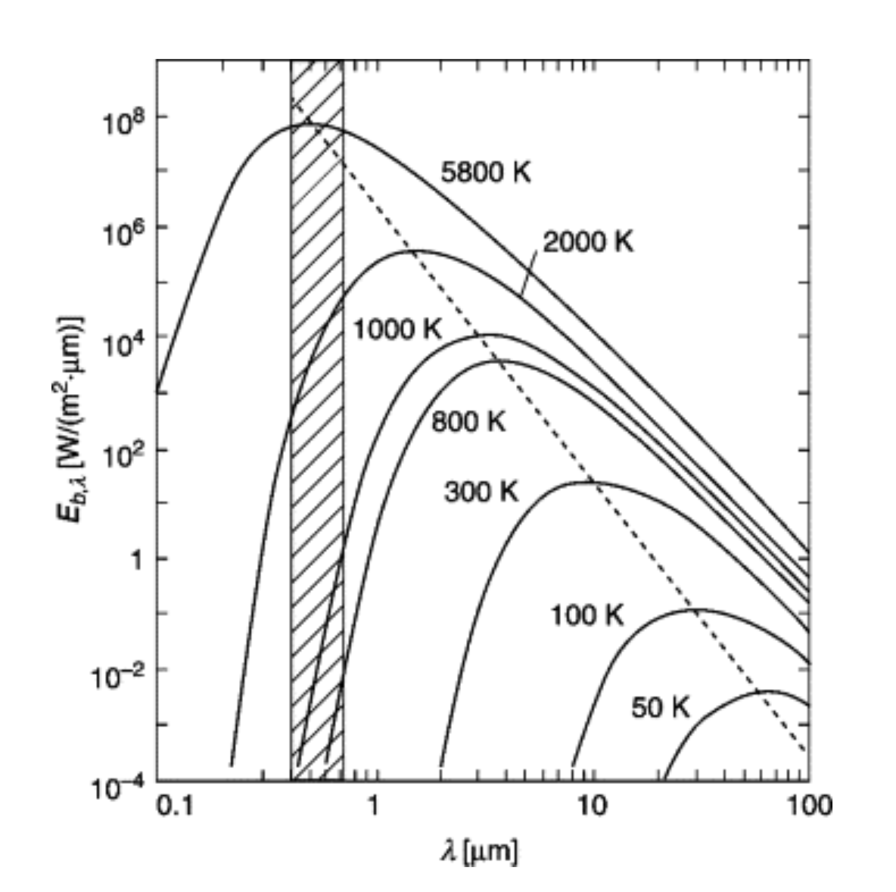

Spectral emissive power of a blackbody, Eb,λ, versus wavelength, λ, according to expression above. Numbers in the curves indicate the blackbody temperature, T. The striped area indicates the visible spectral region.

Ref: https://www.sciencedirect.com/topics/engineering/blackbody

Looking for cool down too however, mainly radiative cooling at steady state with laser on at cryogenic temperatures is to be explored

**Aims:**

**1) Emissivity of test mass barrel > 0.5 at long wavelengths in micron range (peak of radiative emission at cryogenic temperatures)**

**2) Low outgassing/able to withstand Ultra High Vacuum** (what is unacceptable level of Total Mass Lost (TML) for UHV?)

**3) Robust to handle and clean**

(What are the present cleaning procedures or ideal ones?)

**Obvious notes:** Firstly we need to make sure the barrel is not coated with something that happens to have a lower emissivity at low temperatures/large wavelengths compared to Silicon or doped Silicon itself. Ref: Satō, T., 1967. Spectral emissivity of silicon. Japanese Journal of Applied Physics, 6(3), p.339.

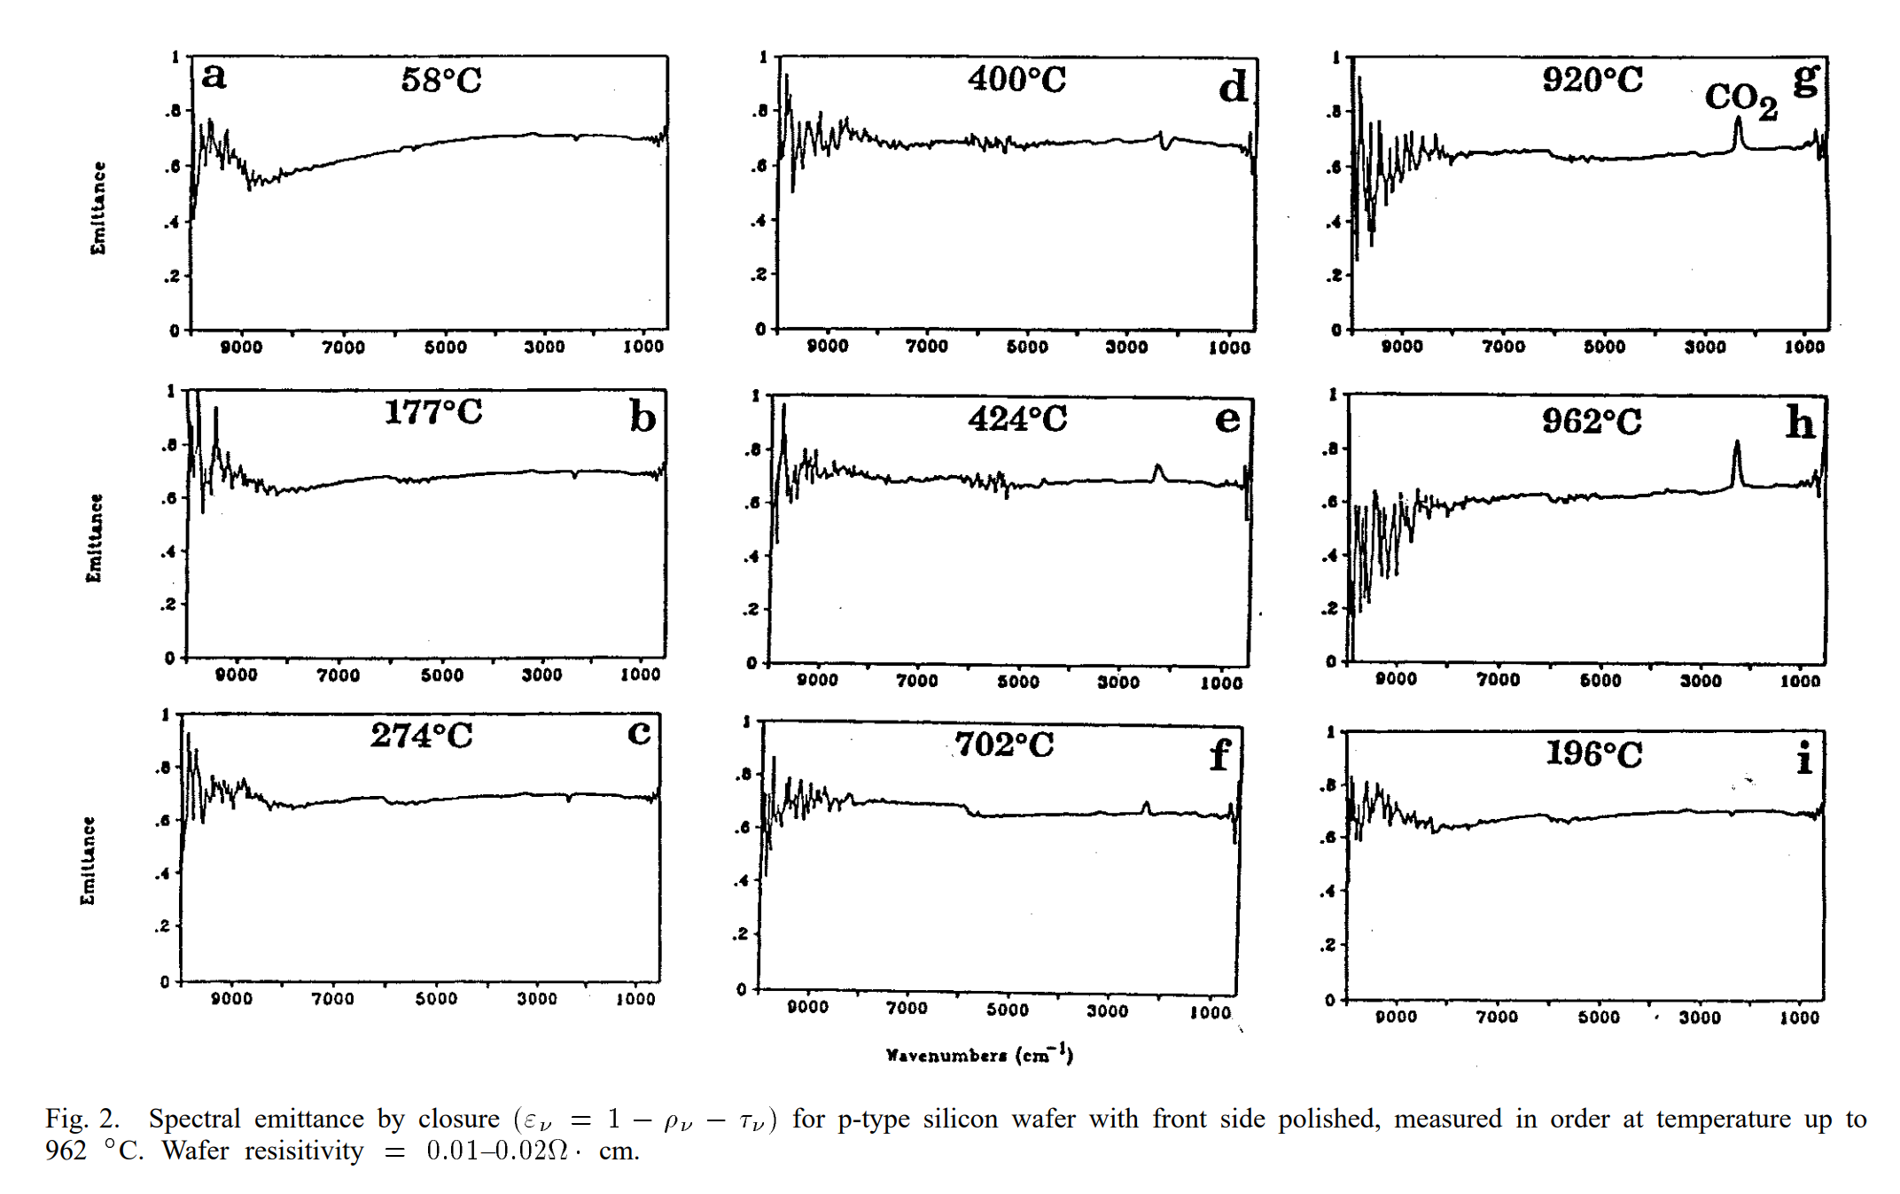

*Ref: Ravindra, N.M., Abedrabbo, S., Chen, W., Tong, F.M., Nanda, A.K. and Speranza, A.C., 1998. Temperature-dependent emissivity of silicon-related materials and structures. IEEE Transactions on semiconductor manufacturing, 11(1), pp.30-39.*

**Measuring Emissivity Experimentally:** Difficult to find instruments (ellipsometers) that go to/past 30 microns however we could extrapolate (using experimental data at shorter wavelengths in literature?) or investigate FTIR set up in the Rossman lab at Caltech to test samples.

It does seem that many contenders which have high emissivities at shorter wavelengths, show a fall in emissivity values for large wavelengths (once its 10s of microns).

**Potential materials solutions to the barrel emissivity:**

**Short terms:**

**Aquadag** 🡪 Aquadag is a trade name for a water-based colloidal graphite coating commonly used in cathode ray tubes. It is manufactured by Acheson Industries, a subsidiary of ICI. Already used for a cool down curve by Koji, August 2021 https://nodus.ligo.caltech.edu:8081/QIL/2629

**Aeroglaze Z306 black paint** 🡪 AEROGLAZE® Z306 POLYURETHANE COATING BLACK for example from: <https://www.ellsworth.com/products/by-manufacturer/socomore/surface-preparation-materials/protective-coating/socomore-aeroglaze-z306-polyurethane-coating-black-1-gal-can/>

At longer wavelength infrared region, the Aeroglaze Z306 shows superior performance with its higher spectral emissivity values. The emissivity of this material is documented: Maloney, Patrick G., et al. "Emissivity of microstructured silicon." Applied optics 49.7 (2010): 1065-1068.

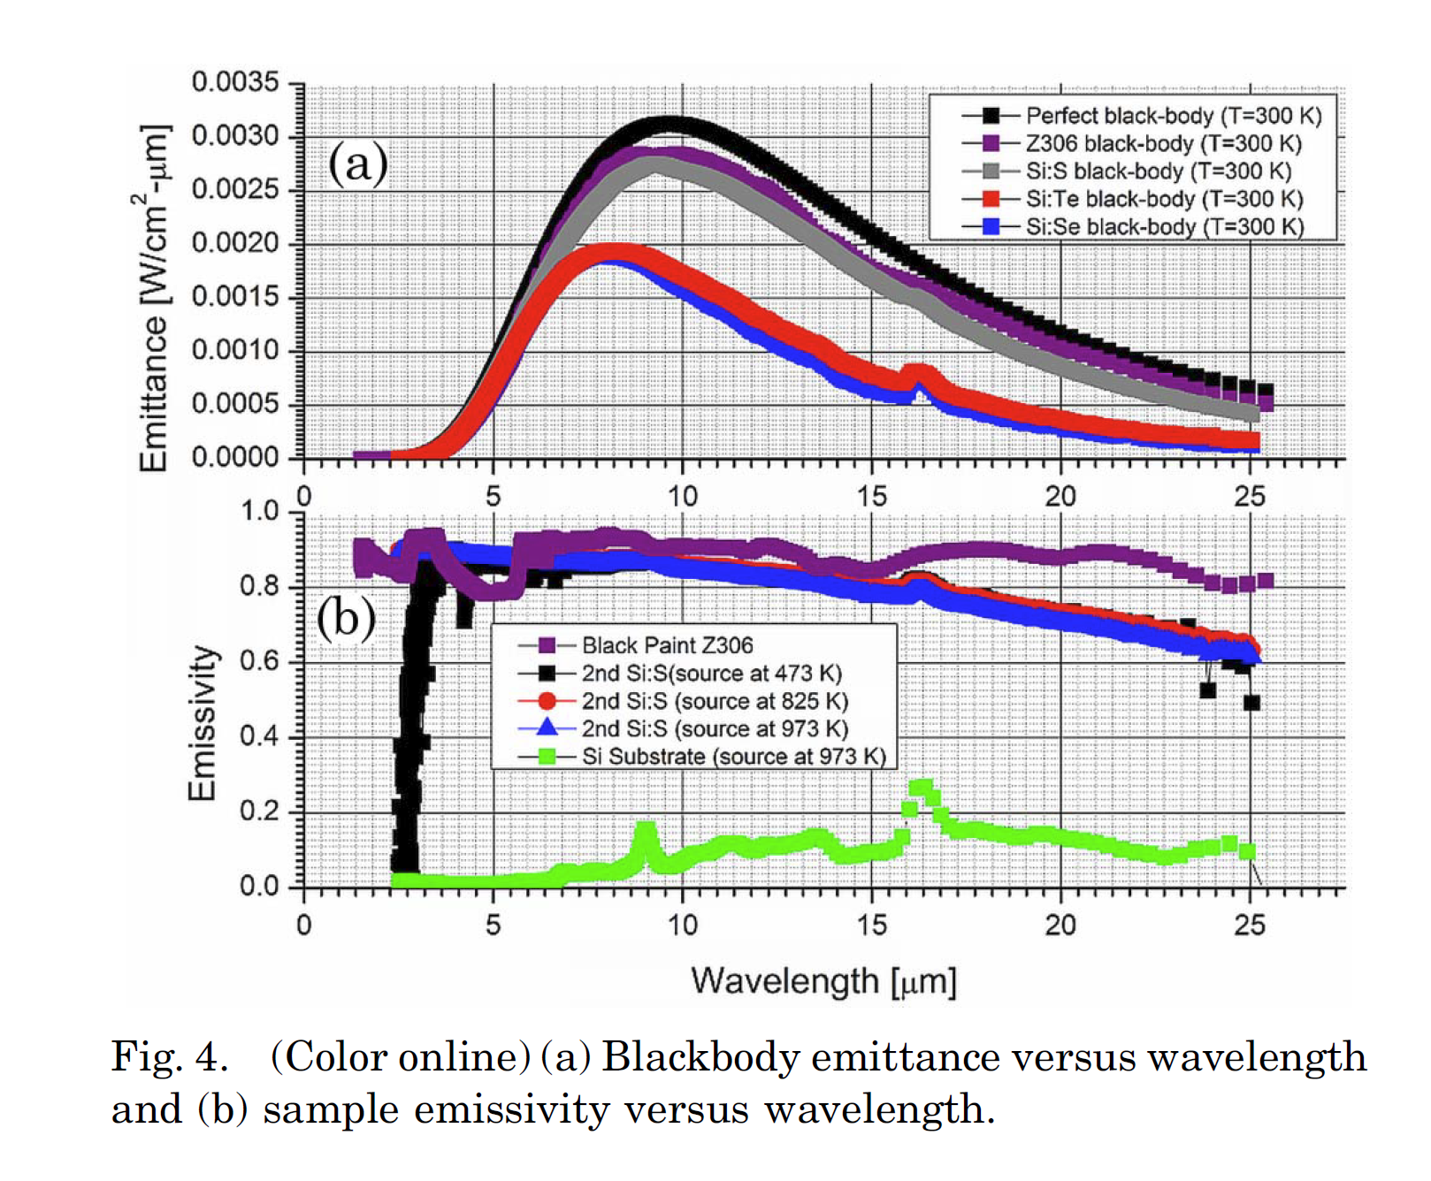

Polyurethane can be used in the temperature range of -60°C to 90°C generally, not totally sure what will happen at cryogenic temperatures to the cured coating- this is an unknown. One can not get better/easy to handle surfaces than cured polyurethane – they are hard and enamel-like after cure and these layers adhere to the substrate well.

I have used curable polymers like these in an evaporator that goes to vacuum for depositing other things on it, and it was fine. They say Z306 is aerospace grade, I have contacted Socomore for details of their Aeroglaze Z306 and what tests did they do for aerospace grade, so they should be writing back soon.

**Long term:**

**Black Silicon:** can be considered as a surface treatment to the underneath Silicon for example, via reactive ion etching (RIE). Handling spaces can be left unetched if necessary. However, there will be a great thermal ‘contact’ and we are etching this within the substrate Silicon surface and cryogenic temperatures shouldn't be an issue. More data: Ravindra, N. M., S. R. Marthi, and S. Sekhri. "Modeling of optical properties of black silicon/crystalline silicon." Silicon. J Sci Ind Metrol 1.1 (2015): 1.

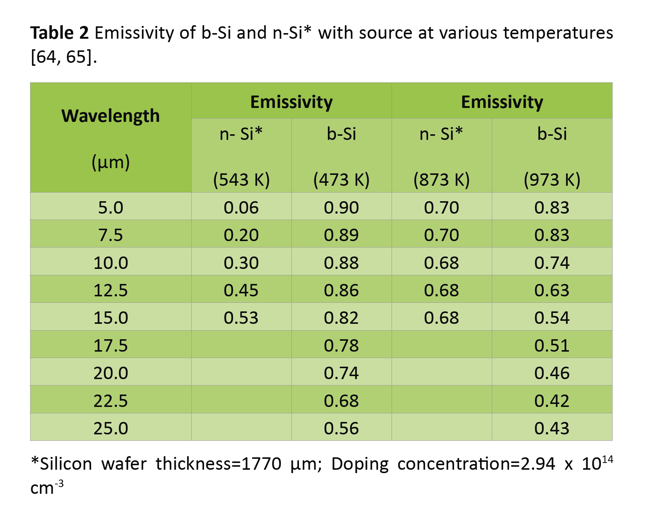

b-Si is Black Silicon and n-Si is n-doped Silicon at doping concentration=2.94 x 10^14 cm-3

Black Silicon is easy to make and not a nanostructure that needs lithography and masking steps etc, it will be an intrinsic layer part of the Silicon test mass so won't 'delaminate', its won't be sticky or messy. We can leave handling areas if needed. Black Silicon has well documented experimental emissivities even in the IR. I am also trying to search if Black Silicon is robust enough. However, it is still a structured Si surface and the tips of which can be damaged while handling and can not be cleaned easily.

*Ref: Liu, X., Coxon, P.R., Peters, M., Hoex, B., Cole, J.M. and Fray, D.J., 2014. Black silicon: fabrication methods, properties and solar energy applications. Energy & Environmental Science, 7(10), pp.3223-3263.*

*Liu, Y., Das, A., Lin, Z., Cooper, I.B., Rohatgi, A. and Wong, C.P., 2014. Hierarchical robust textured structures for large scale self-cleaning black silicon solar cells. Nano Energy, 3, pp.127-133.*

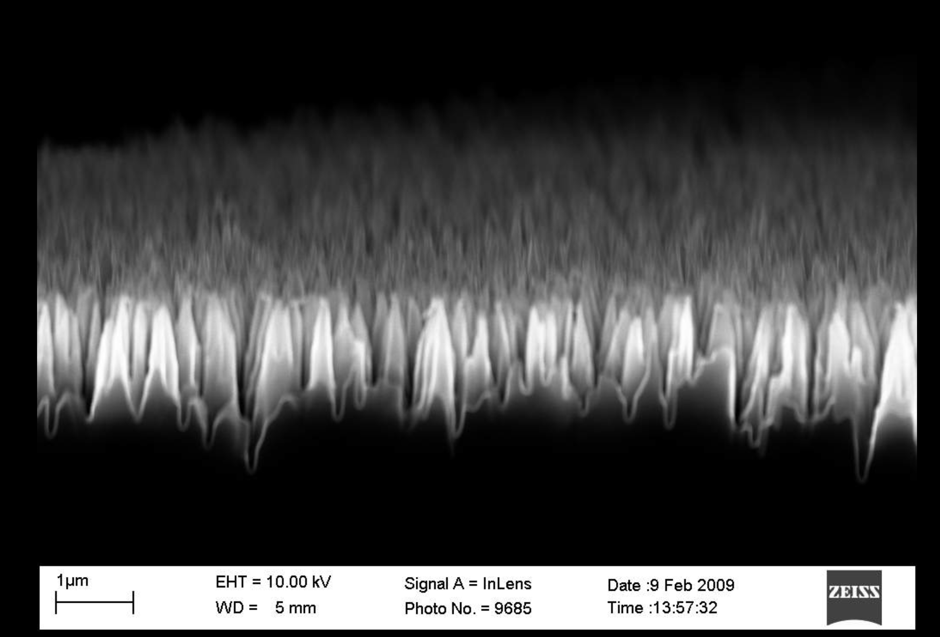

*SEM micrograph of black silicon formed by cryogenic RIE. Notice the smooth, sloped surfaces, unlike the undulated sidewalls obtained with the Bosch process RIE.*

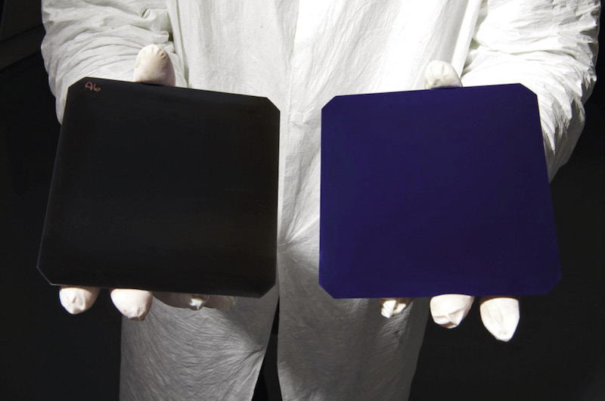

*https://www.pv-magazine.com/2018/01/04/suntechs-black-silicon-solar-cells-enter-mass-production/*

**SiO2 passivation and encapsulation** of microstructures with a baking step can make the tips stronger for handling, perhaps 🡪 need to investigate this idea more! Another one I am looking at is porous Silicon

**DLC:**

References:

1. T. Kunii, M. Horiuchi, S. Kodama, K. Kuroda Anritsu Technical, 65 (1993), p. 55 (its in Japanese)
2. Takahashi, R., et al. "Application of diamond-like carbon (DLC) coatings for gravitational wave detectors." Vacuum 73.2 (2004): 145-148. 'Anritsu Co. developed an ultra-black NiP (“UB-NIP”) film with a reflectivity less than 1% for the infra-red (IR) light successfully. The surface resembles like mohair cloth owing to etching by nitric acid.'
3. Also KAGRA cooling curves with DLC: Sakakibara, Y., et al. "A study of cooling time reduction of interferometric cryogenic gravitational wave detectors using a high-emissivity coating." AIP Conference Proceedings. Vol. 1573. No. 1. American Institute of Physics, 2014.

DLC will need Plasma Assisted Chemical Vapor Deposition (PACVD). Some more notes from literature study are that DLC delaminates from surfaces easily due to its extreme hardness.

KAGRA did use DLC for cool down of scaled down test mass, experimentally. However, at low temperature (i.e. steady state in Mariner) their formula indicated a very low emissivity.

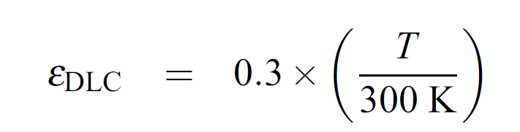

*Rana: ‘I think the KAGRA cooldown is not very useful to us, since they mostly rely on conductive, rather than radiative cooling.’*

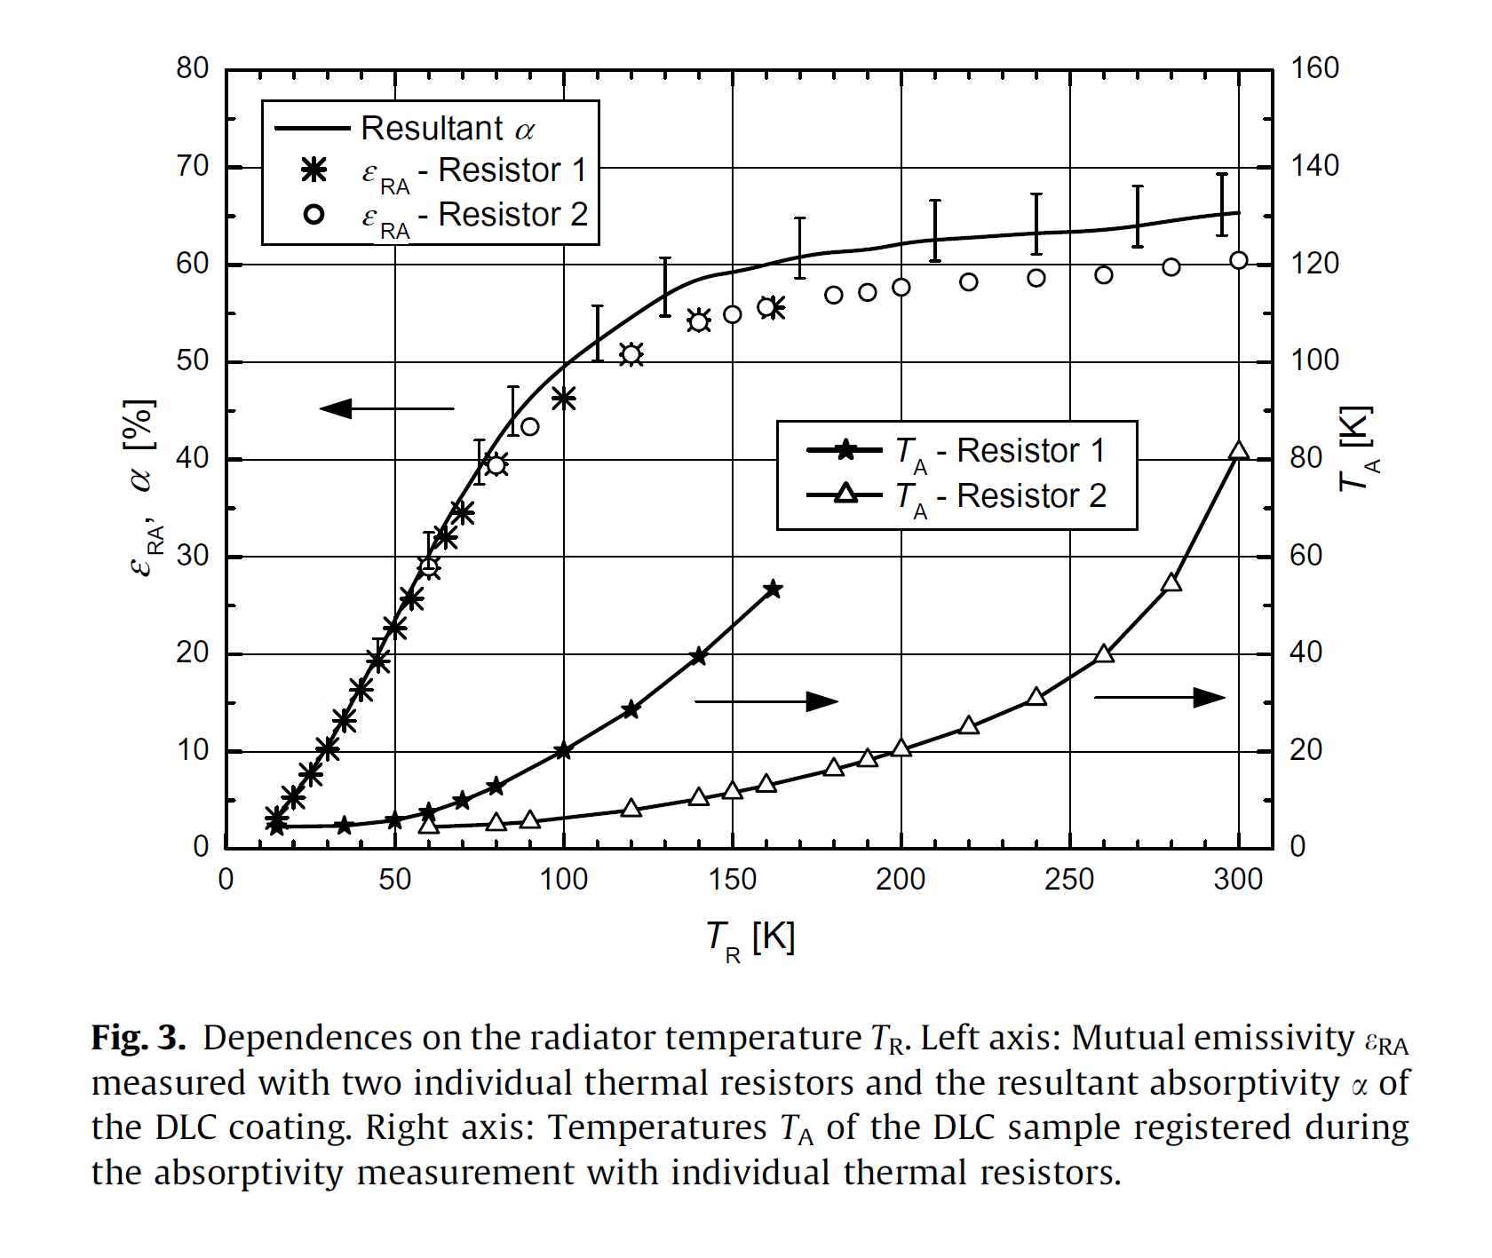

Ref: Hanzelka, P., Kralik, T., Maskova, A., Musilova, V. and Vyskocil, J., 2008. Thermal radiative properties of a DLC coating. Cryogenics, 48(9-10), pp.455-457.

To look at any more experimental data out there for DLC and other forms of DLC.

**BIRB**

BIRB also has a microstructure (image from paper below). They write about adhesion mechanical properties but not handling robustness. A microstructure is perhaps not cleaning friendly, and in the absence of handling data in these papers, the microstructure and surface properties could be a good indication. There are other issues with BIRB.

*Stephen: Randy's comment about "provide it as part of a larger contract" made me feel like BIRB it was a dead end.*

*Franck, Randy, and Michael Renbarger. "Cryogenic emissivity properties of ball infrared black." AIP Conference Proceedings. Vol. 1434. No. 1. American Institute of Physics, 2012. From Ball Aerospace.*

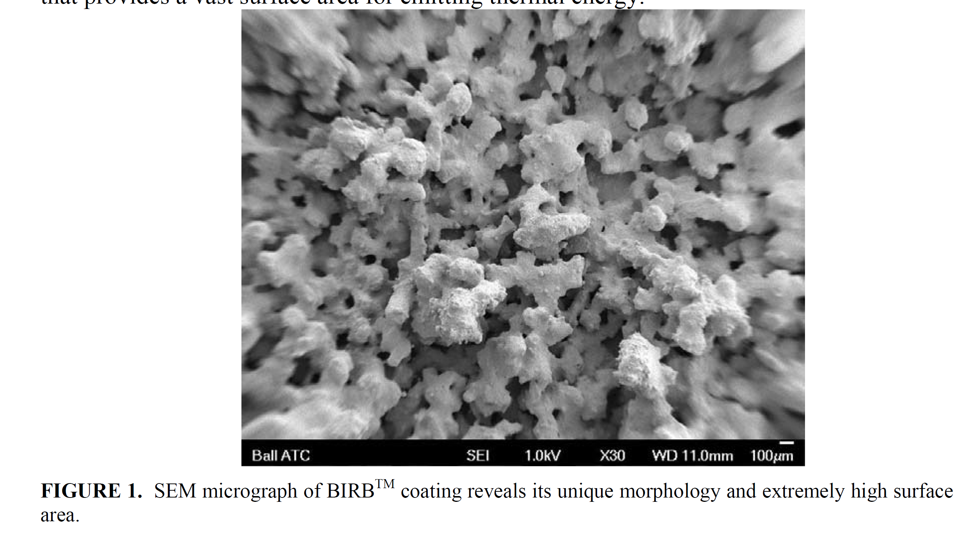

More paint emissivities in here: Tuttle, J. and Canavan, E., 2015, November. Recent NASA/GSFC cryogenic measurements of the total hemispheric emissivity of black surface preparations. In IOP Conference Series: Materials Science and Engineering (Vol. 102, No. 1, p. 012015). IOP Publishing.

**SiC**

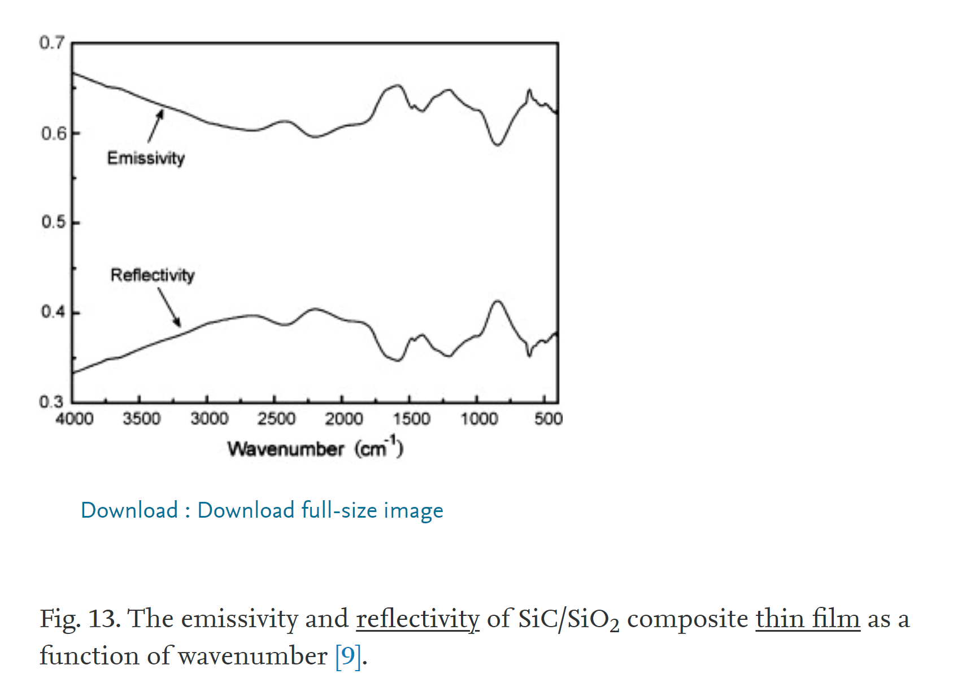 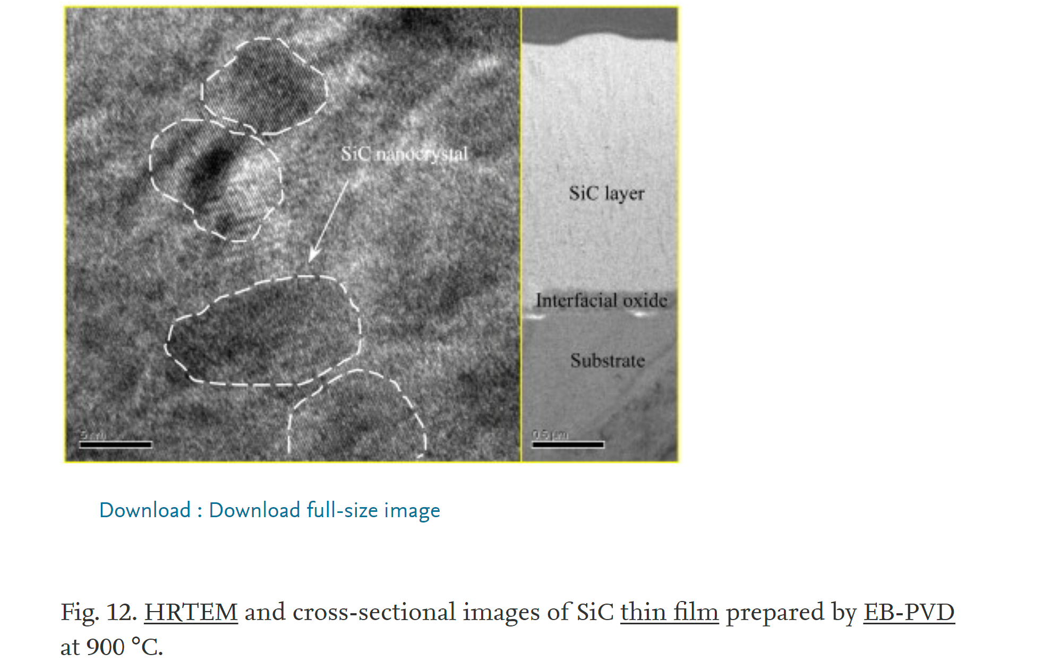

*Ref: He, X., Li, Y., Wang, L., Sun, Y. and Zhang, S., 2009. High emissivity coatings for high temperature application: progress and prospect. Thin Solid Films, 517(17), pp.5120-5129.*

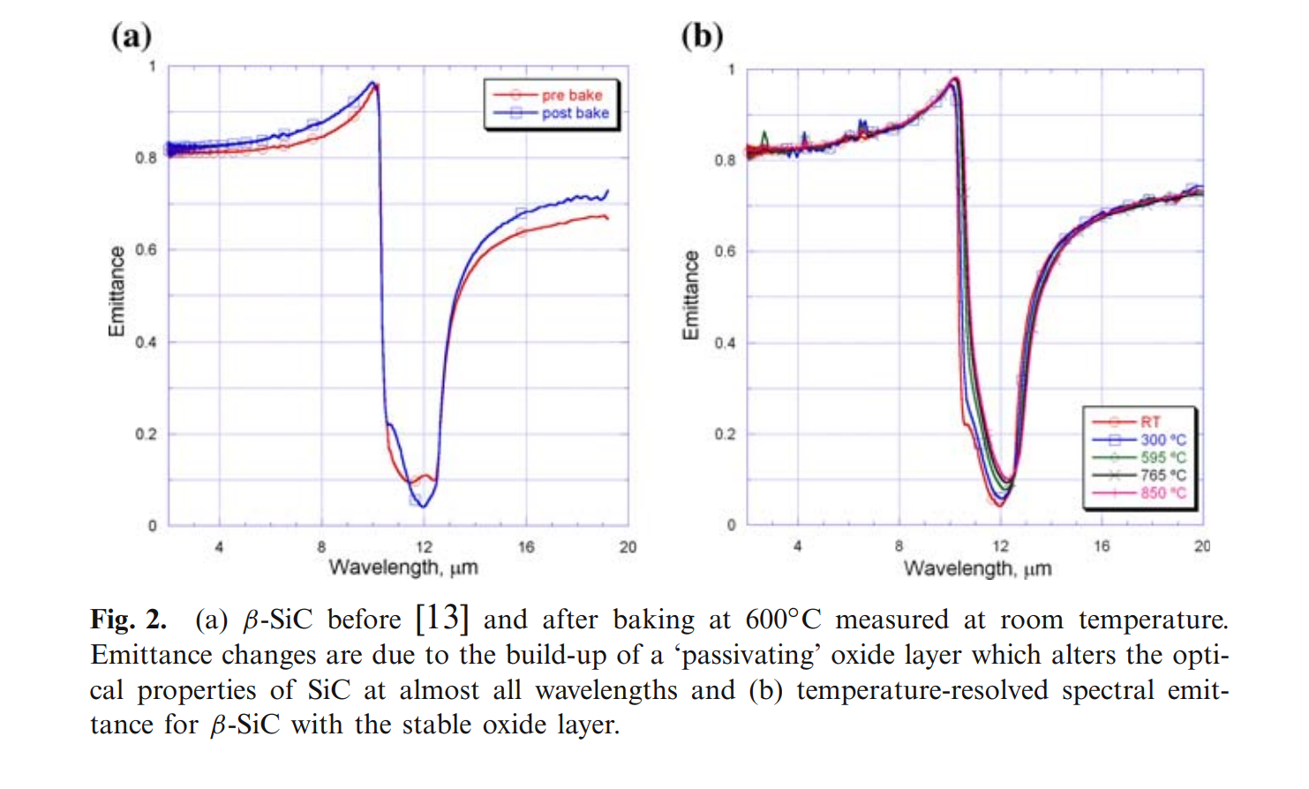

*Ref: Cagran, C.P., Hanssen, L.M., Noorma, M., Gura, A.V. and Mekhontsev, S.N., 2007. Temperature-resolved infrared spectral emissivity of SiC and Pt–10Rh for temperatures up to 900° C. International Journal of Thermophysics, 28(2), pp.581-597.*

*Zhu, M., Chen, J., Ran, N., Zheng, J.Q., Huang, Z.R., Liu, X.J. and Chen, Z.M., 2020. High infrared emissivity of SiC-AlN ceramics at room temperature. Journal of the European Ceramic Society, 40(10), pp.3528-3534.*

*Alketbi, A.S., Yang, B., Raza, A., Zhang, M., Lu, J.Y., Wang, Z. and Zhang, T., 2018. Sputtered SiC coatings for radiative cooling and light absorption. Journal of Photonics for Energy, 9(3), p.032703.*

**AlN**

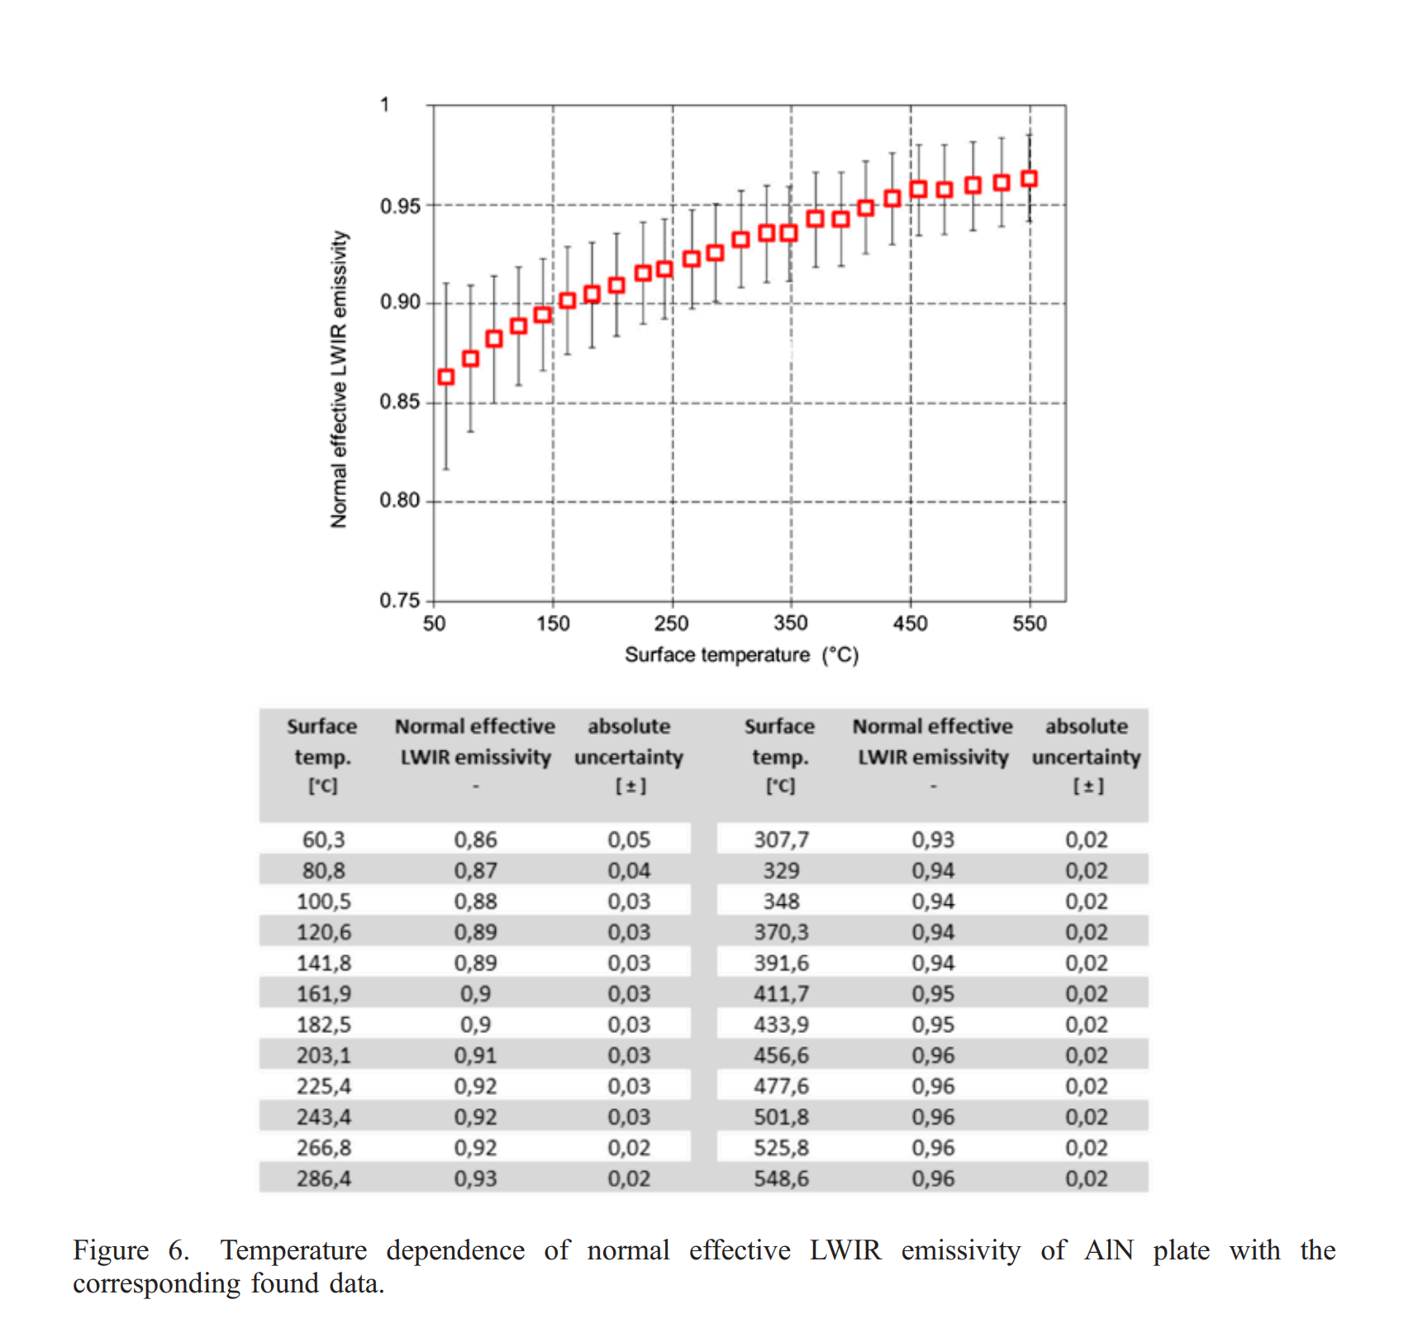

Ref: Riou, O., Logerais, P.O., Froger, V., Durastanti, J.F. and Bouteville, A., 2013. Thermal study of an aluminium nitride ceramic heater for spray CVD on glass substrates by quantitative thermography. Quantitative InfraRed Thermography Journal, 10(2), pp.159-171.

AlN could be a good choice?

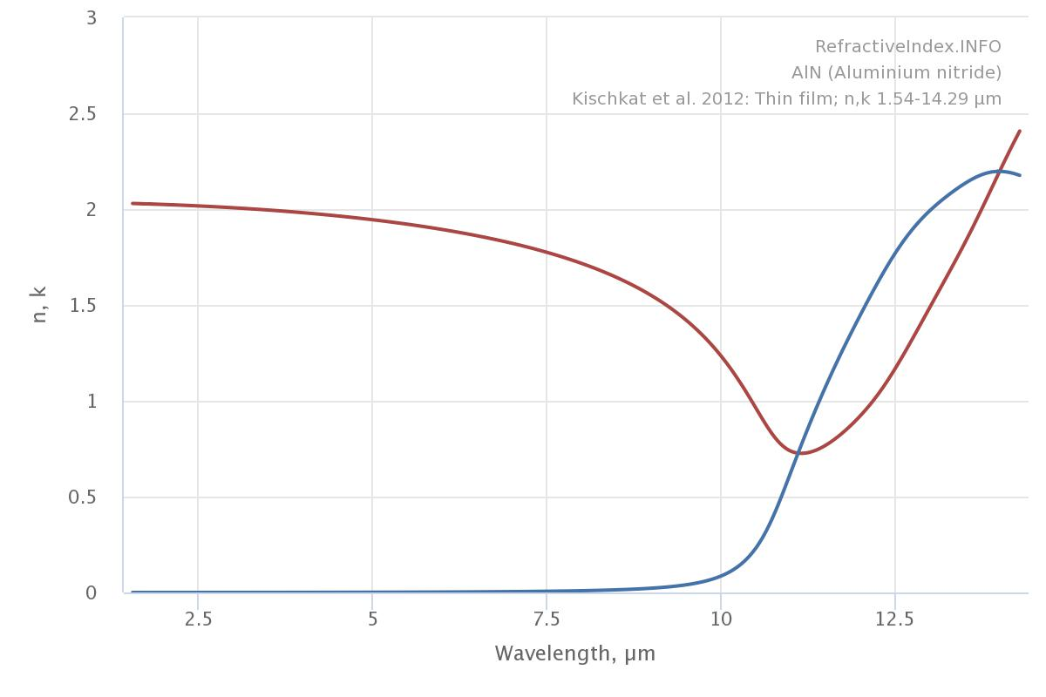

**TiC** could be considered: Groot, P. and Dvorak, M., 1991. High emissivity TiC coatings for a first wall. Fusion Engineering and Design, 16, pp.307-309.

|  |  |  |  |  |
| --- | --- | --- | --- | --- |
| **Material** | **Emissivity** | **Ease of handling** | **TML** | **Results** |
| **Short term:** | | | | |
| Aeroglaze Z306 | 0.8 at 25 microns | Yes | Aerospace grade? | Won’t work |
| Acquadag | ? | No | ? | Won’t work |
| **Long term:** | | | | |
| Black Silicon | High at shorter wavelengths and 0.6 at 25 microns | Not necessarily | Very low to none | Maybe |
| DLC | Very low at low temperatures | Yes | Low | Won’t work |
| SiC | Dip at 12 microns, high otherwise in the tens of microns | Yes | None | Maybe? |
| AlN |  |  |  | Maybe? |
| TiC |  |  |  |  |
| Black Nickle |  |  |  |  |

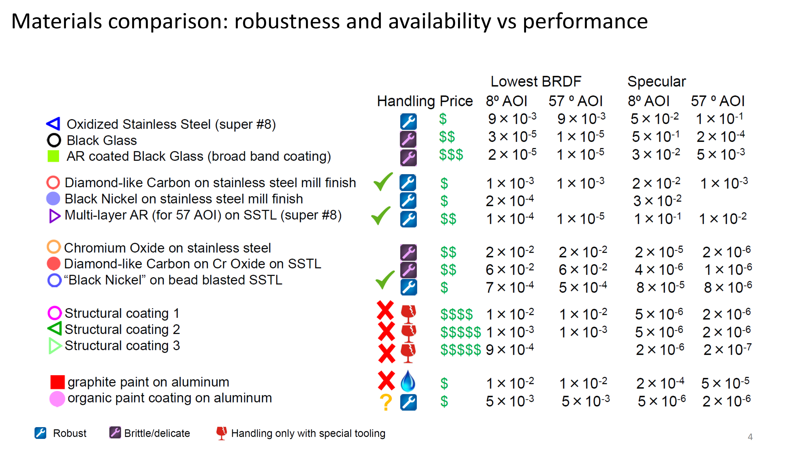

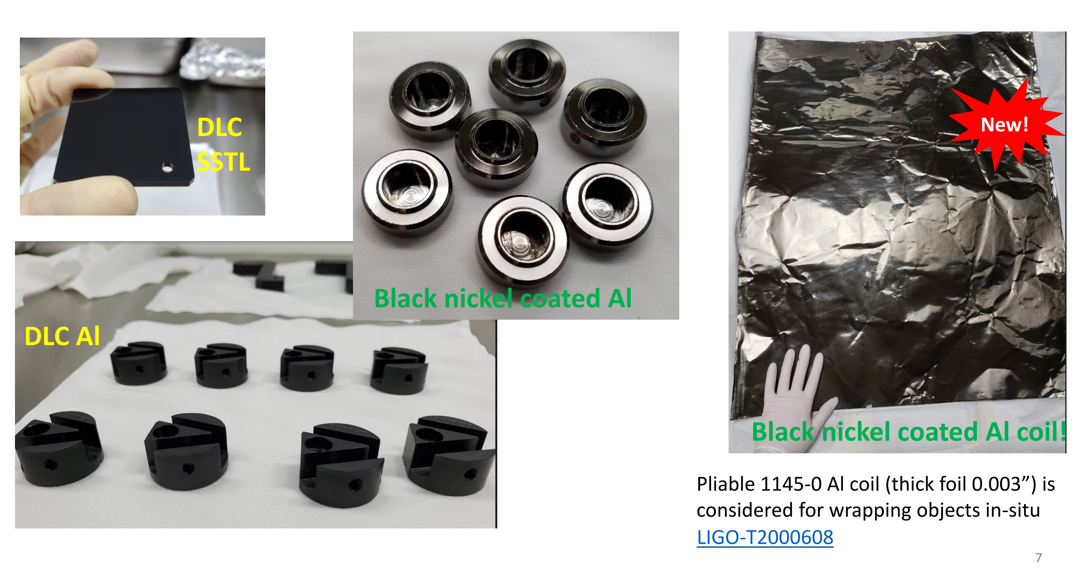

Above two slides from ref: <https://agenda.infn.it/event/26121/contributions/136683/attachments/81537/106884/Stray%20light%20control%20upgrades%20for%20LIGO%204th%20Observation%20run.pdf>

**Vendors:**

**SiC** supplier: <https://www.agc.com/en/products/electoric/detail/roiceram.html>

https://svmi.com/contact/

***Contacted AGC and SVMI for quotation***

Silicon Carbide Deposition Process:

There are two primary ways to deposit silicon carbide: physical vapor deposition (PVD) and plasma enhanced chemical vapor deposition (PECVD). Silicon carbide PVD is performed when powder silicon carbide is turned to vapor using one of two methods: either in a high temperature vacuum or with a gaseous plasma. After vaporizing all the material, it moves to a partial or full vacuum furnace containing the wafers. Once in the furnace, the vapor settles on the substrate surface, which results in a thin carborundum layer. To deposit SiC through PECVD, a CVD furnace exposes the wafers to plasma in order to catalyse the chemical reaction on the substrate surface.

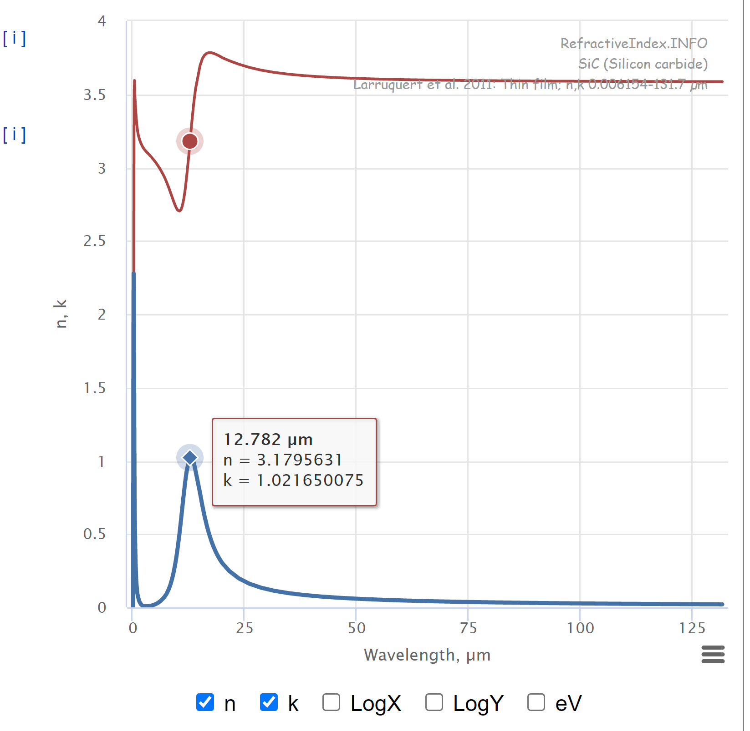

k blue, n red

https://refractiveindex.info/?shelf=main&book=SiC&page=Larruquert

<https://en.wikipedia.org/wiki/Christiansen_effect>

Temperature-Resolved Infrared Spectral Emissivity of SiC and Pt–10Rh for Temperatures up to 900◦C

According to our results, the temperature has the greatest influence on the emittance of SiC at the Christiansen point and in the absorption region. The former is shifted towards longer wavelengths (from about 9.98µm at room temperature to 10.26µm at 850◦C) and to higher absolute emittance values. Temperature-dependent changes of the latter are even larger; the emittance at the absorption edge shifts by more than 0.4µm at the ε = 0.5 level towards longer wavelengths and the maximum absorption decreases with temperature. Such shifting of the reflection band for SiC has also been reported by Roy et al. [15]. As a result, crossover of the emittance isotherms is observed at around 12.6µm. This effect, known as the x-point, has also been found for other materials such as tungsten [16], but is still not theoretically understood. For wavelengths between 16 and 20µm, the emittance isotherms for SiC again become identical and indistinguishable. A literature survey has revealed little data concerning the temperature-dependent emittance of SiC. A collection of available data in the late 1960s at various temperatures (600–1100◦C) is available from Touloukian [17], but the reported emittance numbers in the near IR up to the absorption band vary from 0.85 to 1, preventing any detailed comparison. Newer data from Neuer and Jaroma-Weiland [18] report spectral emissivities of SiC in the 1.3–9µm range at T = 900–1440◦C. They observe temperature-related differences in emittance of 0.84–0.9 at about 6µm and an overall decrease from 0.98 to 0.9 within the 1.3 to 6µm region. Our own published data from earlier measurements [13] are inapplicable for comparison, as the sample has since been ‘passivated’ with a stable oxide layer due to additional heating.

Alpha silicon carbide (α-SiC) is the most commonly encountered polymorph, and is formed at temperatures greater than 1700 °C and has a hexagonal crystal structure (similar to Wurtzite). The beta modification (β-SiC), with a zinc blende crystal structure (similar to diamond, the arrangement of atoms in zincblende structure is the same as diamond cubic structure, but with alternating types of atoms at the different lattice sites), is formed at temperatures below 1700 °C. SiC also has a very low coefficient of thermal expansion (4.0 × 10−6/K) and experiences no phase transitions that would cause discontinuities in thermal expansion.

**Aeroglaze**: <https://www.socomore.com/>

***Contacted Socomore for more info about TML and collected volatile condensable material (CVCM) and asked for quotation***

**Acktar black:**

<http://acktar.com/lp/thank-you.html?submissionGuid=63bcedf9-6665-452d-a703-cf5f89712750>

Emissivity: https://www.acktar.com/products-services/high-emissivity-materials/

**Black Silicon**

In semiconductor technology, reactive-ion etching (RIE) is a standard procedure for producing trenches and holes with a depth of up to several hundred micrometres and very high aspect ratios. In Bosch process RIE, this is achieved by repeatedly switching between an etching and passivation. With cryogenic RIE, the low temperature and oxygen gas achieve this sidewall passivation by forming SiO

2, easily removed from the bottom by directional ions. Both RIE methods can produce black silicon, but the morphology of the resulting structure differs substantially. The switching between etching and passivation of the Bosch process creates undulated sidewalls, which are visible also on the black silicon formed this way.

During etching, however, small debris remain on the substrate; they mask the ion beam and produce structures that are not removed and in the following etching and passivation steps result in tall silicon pillars.[21] The process can be set so that a million needles are formed on an area of one square millimeter.[14]

**Black Nickel**

<https://www.sciencedirect.com/science/article/pii/S2214785320337056?casa_token=J6j0lCjvaIIAAAAA:jiHQTN_mZsHj1nDZYa7pc0RDlFlfc59kgW_nAKDxiuuqScjhwK0v9NSRdj2pHvehVWfJSEv28Q>

<https://www.sciencedirect.com/science/article/pii/S0925838815011731?casa_token=0FFv_j2sIioAAAAA:9jgsgv7LXIvx6k19aKtAepuCoSsaBLpruYlMuhrDqPn-YwogNLlXbtSBn7q94Qogd-NHAKnaYw>

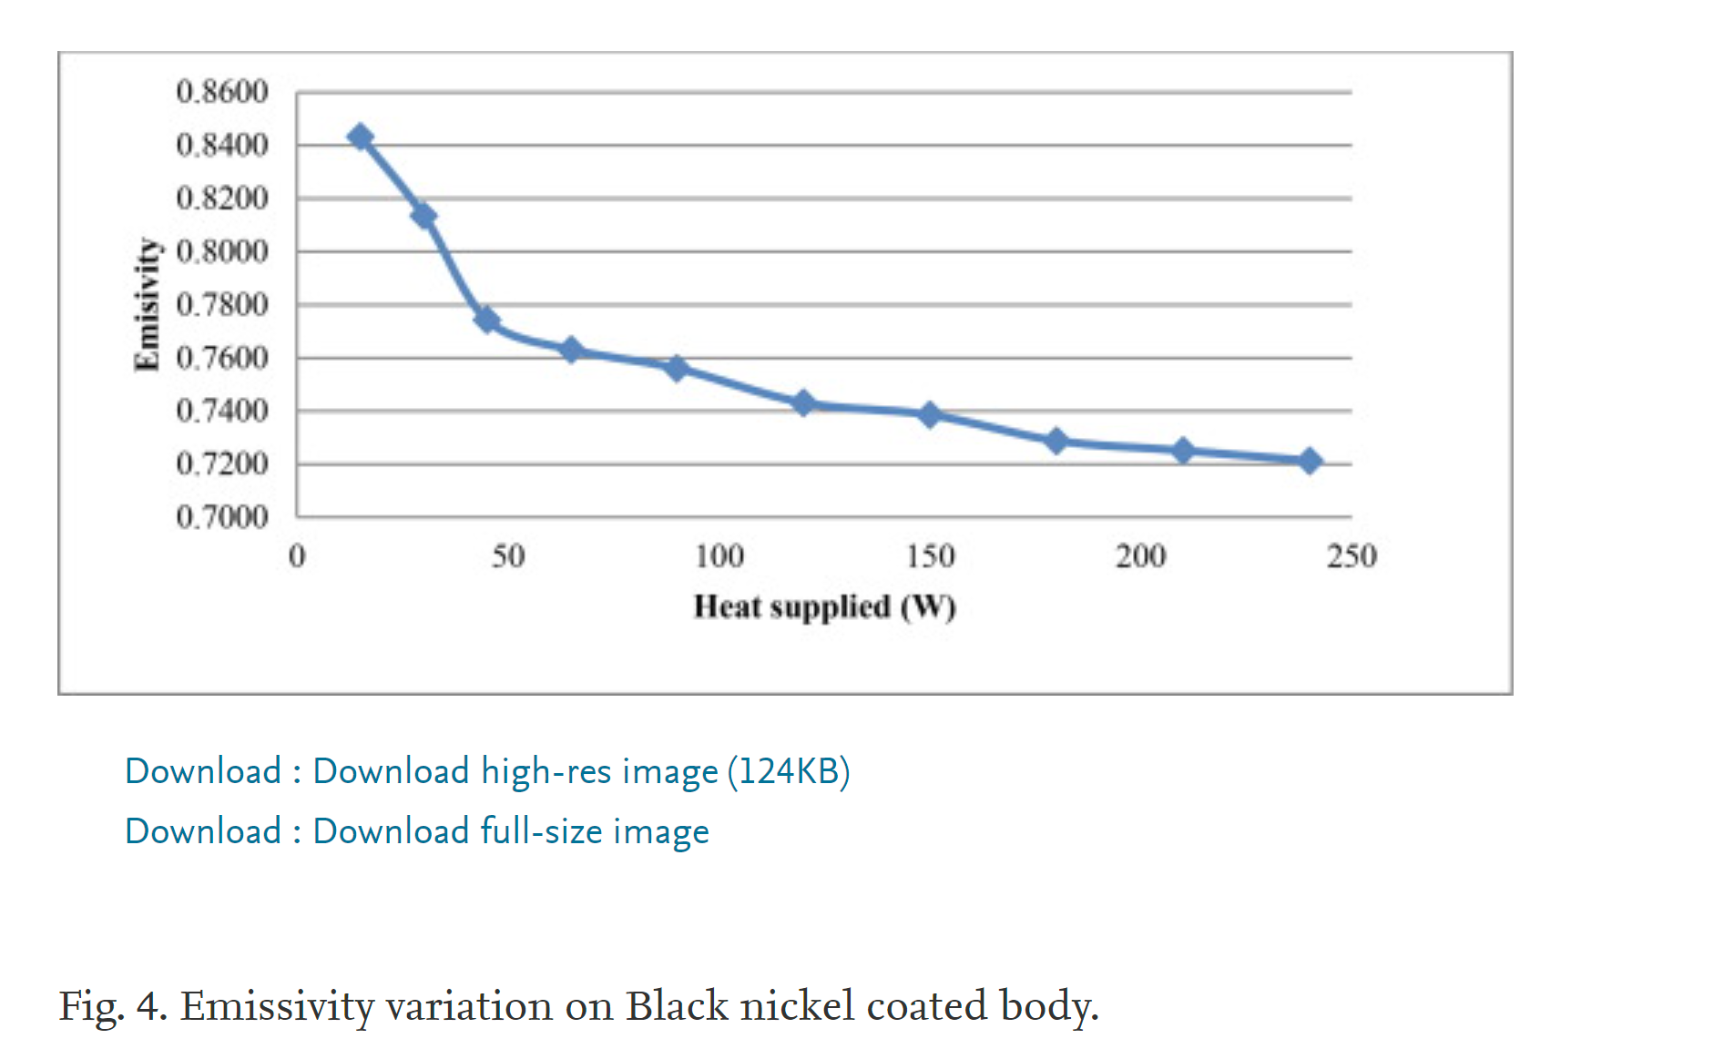

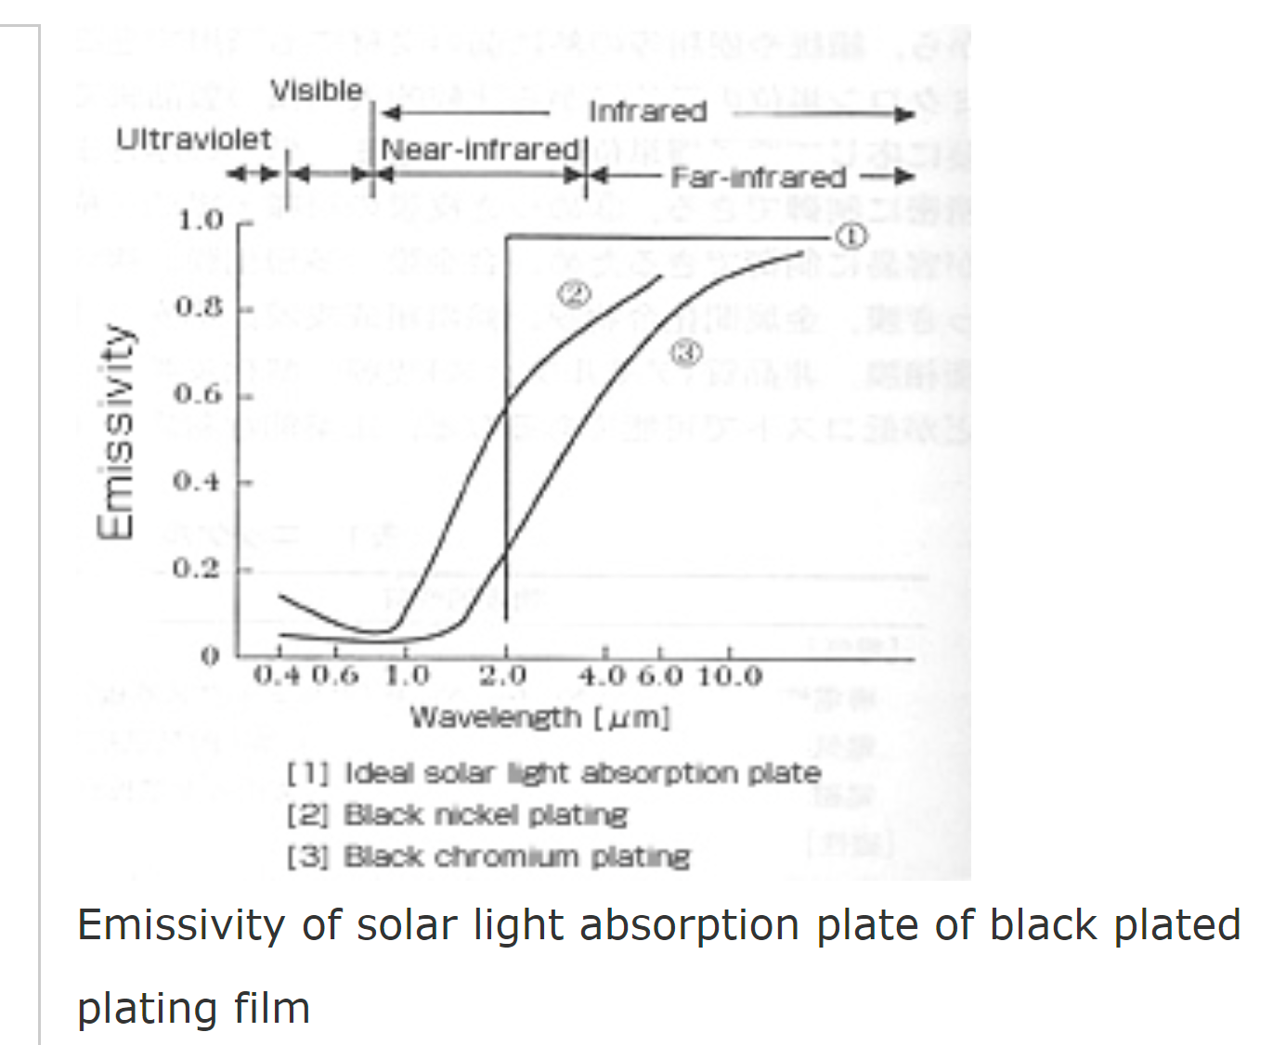

From “Hyomen Shori Kogaku” edited by the Surface Finishing Society of Japan, Nikkan Kogyo Shimbun Ltd.

Black Gold

<https://dcc.ligo.org/DocDB/0027/T080003/001/T080003-04.pdf>

Thermal Noise Increase due to a Gold Coated Barrel

Table:

<https://git.ligo.org/voyager/mariner40/-/wikis/optics/Silicon-test-masses>

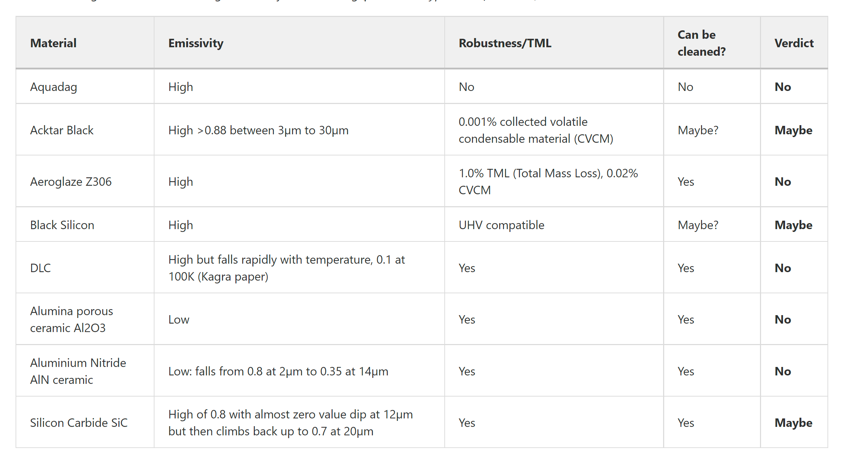

Tool to use:

<https://git.ligo.org/40m/Coatings/-/blob/master/Ta2O5_Voyager/plot_emissivity.py>

27/09/2021:

Some great candidates to basically just run a thin film of -to find emissivity, single film might even work. I am attaching the google drive with all their n and k tables downloaded and pictures of how n and k change.

https://drive.google.com/drive/folders/10-DNhTLx4UnOsrKEPf-1i-x-zQgPY6cq?usp=sharing

The following have high k values at around the cryogenic peak of around 30 microns, the k value graphs are looking very promising for:

TiO2,

Ta2O5,

Zinc Zn,

Tungsten W,

Lead Pb and

SiC (just to check from before for completion even if it has low k values)

